Website Content & Strategy Questionnaire
Project: bemore Design Studio Website Development
Objective: To capture the brand essence and operational details for a high-converting digital web presence.

1. Brand Identity & Vision
- The "Elevator Pitch": In 2 sentences, how do you describe your design style to a new client?
Clean, intentional spaces that balance aesthetics with real-life functionality, everything has a purpose. We design homes that feel effortless and personal, where materials, light, and layout work together to create a calm, elevated everyday experience.
- Design Philosophy: What is the core belief behind your work? (e.g., "Function over form," "Luxury is in the details," "Sustainable living").
Function first, form follows.
Every space is planned with clarity, proportion, and purpose which is built to last.
- Target Audience: Who is your ideal client? (e.g., First-time homeowners, corporate office managers, luxury villa owners).
Residential, Hospitality, commercial, and corporate clients seeking clarity, efficiency, and precision in design. For those who value well-planned spaces that function seamlessly and stand the test of time.

2. Team & Story (About Page)
- Founding Story: What year was the firm started, and what was the inspiration behind it?
Established in the year 2023, inspired to bring clarity and precision into the design process, the firm approaches every project with a focus on function, proportion, and long term performance.
Today, the studio works across residential, hospitality, commercial, and corporate spaces, delivering architecture and interiors that are efficient, refined, and built to last.
- Principal Profiles: Please provide a short professional bio (150 words) for the owners/lead architects. (a general brief about us)
ABOUT THE FOUNDERS
KAVYA SREENIVAS AND SURAJ DIVATE
Built on Clarity. Designed with Purpose. Delivered with Precision.
Two Founders. One Vision. One Evolving Story.
beMore Design Studio is an Architectural and interior design practice based in Bengaluru, founded by Kavya and Suraj, partners in building spaces that are thoughtful, functional, and enduring.
The studio began with a shared belief: that good design is not just about how a space looks, but how it works, feels, and adapts over time. What started as a pursuit to create better, more intentional spaces gradually evolved into a structured practice grounded in clarity, planning, and detail.
Kavya leads the design direction, shaping each project through a strong focus on proportion, material, and spatial experience. Suraj anchors execution and on-site coordination, ensuring that every design is translated with precision and discipline. Together, they bring a balanced approach, where creativity is supported by process, and ideas are carried through with clarity.
At beMore, every project begins with understanding how the space will be used, who it is for, and what it needs to achieve. The process is methodical yet flexible, allowing each design to respond to its context while maintaining a clear framework.
The studio works across residential, commercial, and corporate projects, delivering spaces that are efficient, well-resolved, and built to last. Each project reflects a consistent approach—clean design, strong planning, and attention to detail.
For Kavya and Suraj, design is not about excess , it is about intention.
And through every project, the goal is simple: to create spaces that do more, and do it better.
- Accreditations: Are you registered with the Council of Architecture (COA) -yes

3. Services & Specializations
- Service Categories: Please check all that apply:
  - Residential (Apartments/Villas)
  - Commercial (Offices/Retail)
  - Hospitality (Cafes/Hotels)
  - Turnkey (Design + Execution)
  - renovation
  - Consultations Only
- Unique Offerings: Do you offer specific niche services like Vastu-compliant design, 3D VR walkthroughs, or bespoke furniture design? Basic vastu, 3D WALKTHROUGHS
Services
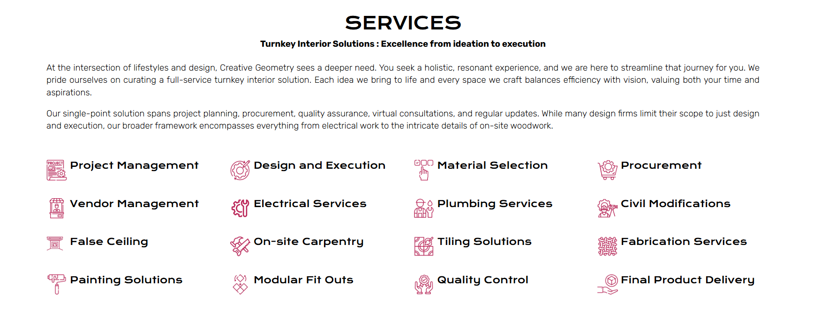

4. Operational Workflow (Work Process)
- The Journey: Please list the typical steps from the first phone call to handing over the keys.
Discover & Design Concept
We start with you: your needs, your story, your space. This phase includes site visits, budget discussions, and gathering inspiration to define the project scope and goals clearly. Based on this we create solutions that fit the space and feel just right with conceptual design presentation and a pre-design estimate.

Design Development & Detailed planning
Once the concept is approved, we translate the ideas into layouts, mood boards, 3D visualizations, and technical drawings to explain our design intent and meticulously curate materials for the project. Every aspect of the space is thoughtfully designed, with attention to details.

Production and Delivery
Once BOQ is approved by the client, we translate approved designs into reality with our trusted vendors, suppliers and service partners, ensuring quality craftsmanship and timely delivery. Regular site supervision, transparent communication, and attention to detail ensure your vision is brought to life — just as imagined.

(e.g., Site Visit -> Moodboard ->2D/3D Renders ->Procurement -> Execution).
- Typical Timeline: What is the average duration for a 3BHK project or a mid-sized office?
60 DAYS. T&C*

5. Projects & Partnerships
- Project Details: For your top 5 projects, please provide:
  - Project Name & Location.
- ROOTED HOME (Architecture+Interiors), Independent House, RT NAGAR, BANGALORE
A home shaped by continuity—where an existing tree was carefully relocated, allowing its life to extend beyond the site. Designed around a central pooja space, the house brings together light, water, and greens to create a calm, inward-focused environment that feels grounded and enduring.
- Elevé Living (Interiors), Brigade Panorama, Bangalore
A residence designed to reflect a refined, modern lifestyle—balancing comfort with high-end finishes.From the bay window seating to the full-height TV unit and a carefully detailed pooja space, every element is tailored for both function and visual clarity, resulting in a home that feels polished, warm, and complete.

  - The "Problem" (The client's original struggle).
  - The "Solution" (How your design fixed it).
- Vendors: Which brands do you frequently collaborate with? (e.g., Kohler, Hafele, Asian Paints, etc.). Highlighting these builds trust in your quality.
Hettich, ebco livsmart, Rehau, Asian Paints, Hafele, Asian Paints, Saint Gobain, Merino Laminates, Century Laminates.

6. Technical & Administrative
- Contact Info: 9663424256 , EMAIL - THE ONE THAT YOU HAVE CREATED, address - 2nd floor, 372/1, 8th A Main Rd, 3rd Stage, Basaveshwar Nagar, Bengaluru, Karnataka 560079
- Social Media: https://www.instagram.com/bemoredesignstudio?igsh=MWNtdG4xb2szbGw0aw%3D%3D&utm_source=qr
- Lead Capture: On the contact form, what specific info do you need? (e.g., "Budget Range," "Project Type," "Expected Start Date"). https://www.creativegeometry.in/contact-us/ (something like this)
- FAQ: FOLLOW AANTRIK FAQ. VERY COMMON

7. Asset Checklist (Please Attach)
- [ ] Logo: High-resolution (Vector/SVG or PNG).
- [ ] Photography: Professional photos of completed projects (organized by project name).
- [ ] Testimonials: 3–5 written reviews from past clients.
- [ ] Brand Colors: Specific Hex codes if you have them (e.g., #2D2D2D).

